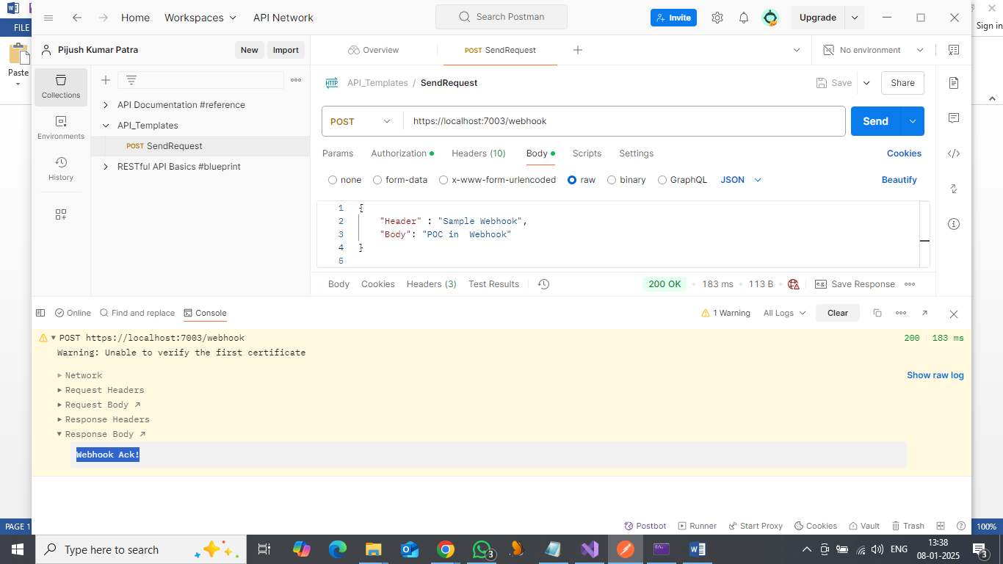

1. Execute the project -Webhook_Test

It will generate the Webhook callback URL <https://localhost:7003/webhook>

1. Open Postman

Use POST method for the Webhook generated callback URL

Method : POST , URL : <https://localhost:7003/webhook>

1. Authorization value needs to be filled in Header.

Authorization ="APIKEY"

1. In postman tab “body” use RAW and JSON format.

Past the below JSON

JSON

{

Header : "value"

Body: "Value"

}

1. Send the request

Response Code

200 OK

Webhook Ack!